

07 - Functions

Department of Computer Science and Engineering

| Rajalakshmi Engineering College

PA. GE

Ex. No. : 7.1 Date: 09.05.2024

Register No.: 231401020 Name: BHUVANESWARI S

Abundant Number

An abundant number is a number for which the sum of its proper divisors is greater than the number itself. Proper divisors of the number are those that are strictly lesser than the number.

Input Format:

Take input an integer from stdin

Output Format:
Return Yes if given number is Abundant. Otherwise, print No

Example input:
12
Output:

Yes
Explanation

The proper divisors of 12 are: 1, 2, 3, 4, 6, whose sum is 1 + 2 + 3 + 4 + 6 = 16. Since sum of proper divisors is greater than the given number, 12 is an abundant number.
Example input:

13

Output:
No

Explanation
The proper divisors of 13 is: 1, whose sum is 1. Since sum of proper divisors is not greater than the given number, 13 is not an abundant number.

For example:
Test Result

print(abundant(12)) Yes
print(abundant(13)) No

def abundant(n):

l,s=[],0

for i in range(1,int(n//2)+1):

if(n%i==0):

l.append(i)

Department of Computer Science and Engineering | Rajalakshmi Engineering College

PA.

GE

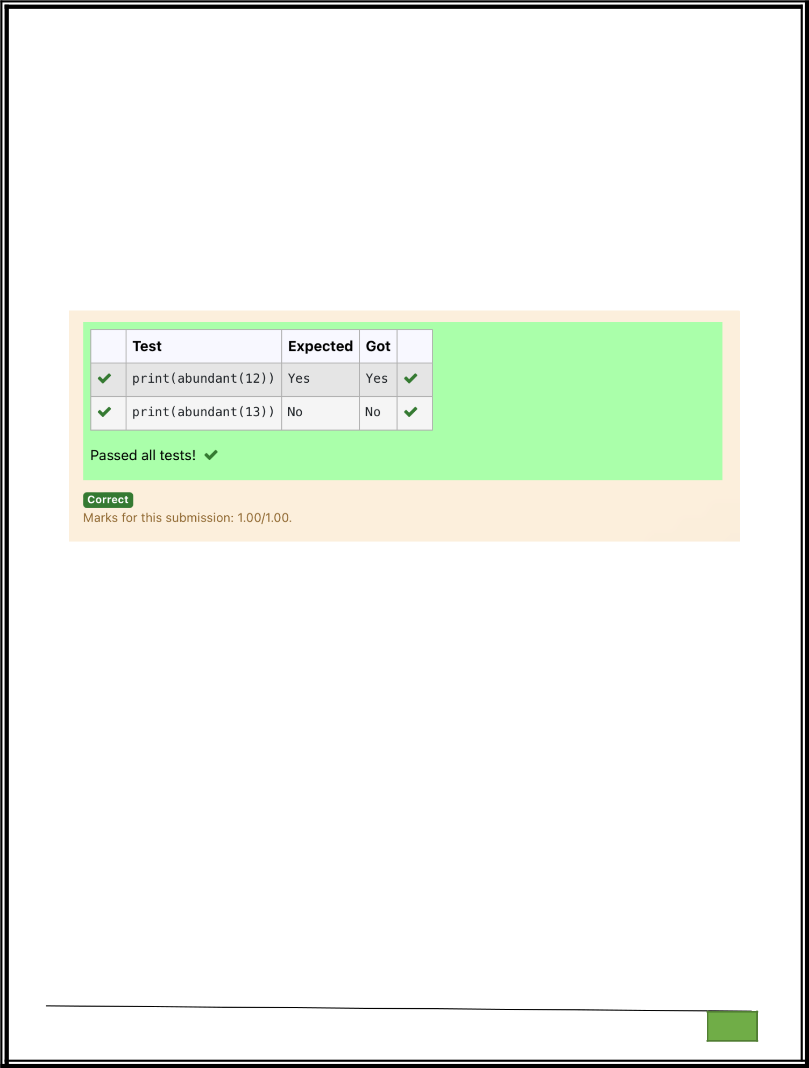
for i in l:

s+=i

if(s>n):

return("Yes")

else:

return("No")

Department of Computer Science and Engineering

| Rajalakshmi Engineering College

PA. GE

Department of Computer Science and Engineering

| Rajalakshmi Engineering College

PA. GE
Ex. No. : 7.2 Date: 09.05.2024

Register No.: 231401020 Name: BHUVANESWARI S

Automorphic number or not

An automorphic number is a number whose square ends with the number itself. For example, 5 is an automorphic number because 5*5 =25. The last digit is 5 which same as the given number.

If the number is not valid, it should display “Invalid input”.

If it is an automorphic number display “Automorphic” else display “Not Automorphic”.

Input Format:
Take a Integer from Stdin

Output Format:
Print Automorphic if given number is Automorphic number, otherwise Not Automorphic

Example input: 5 Output: Automorphic Example input: 25 Output: Automorphic

Example input: 7 Output: Not Automorphic
For example:

Test Result
print(automorphic(5)) Automorphic

def automorphic(n):

a=str(n*n)

if(int(a[-1])==n):

return("Automorphic")

else:

return("Not Automorphic")

Department of Computer Science and Engineering | Rajalakshmi Engineering College

PA.

GE

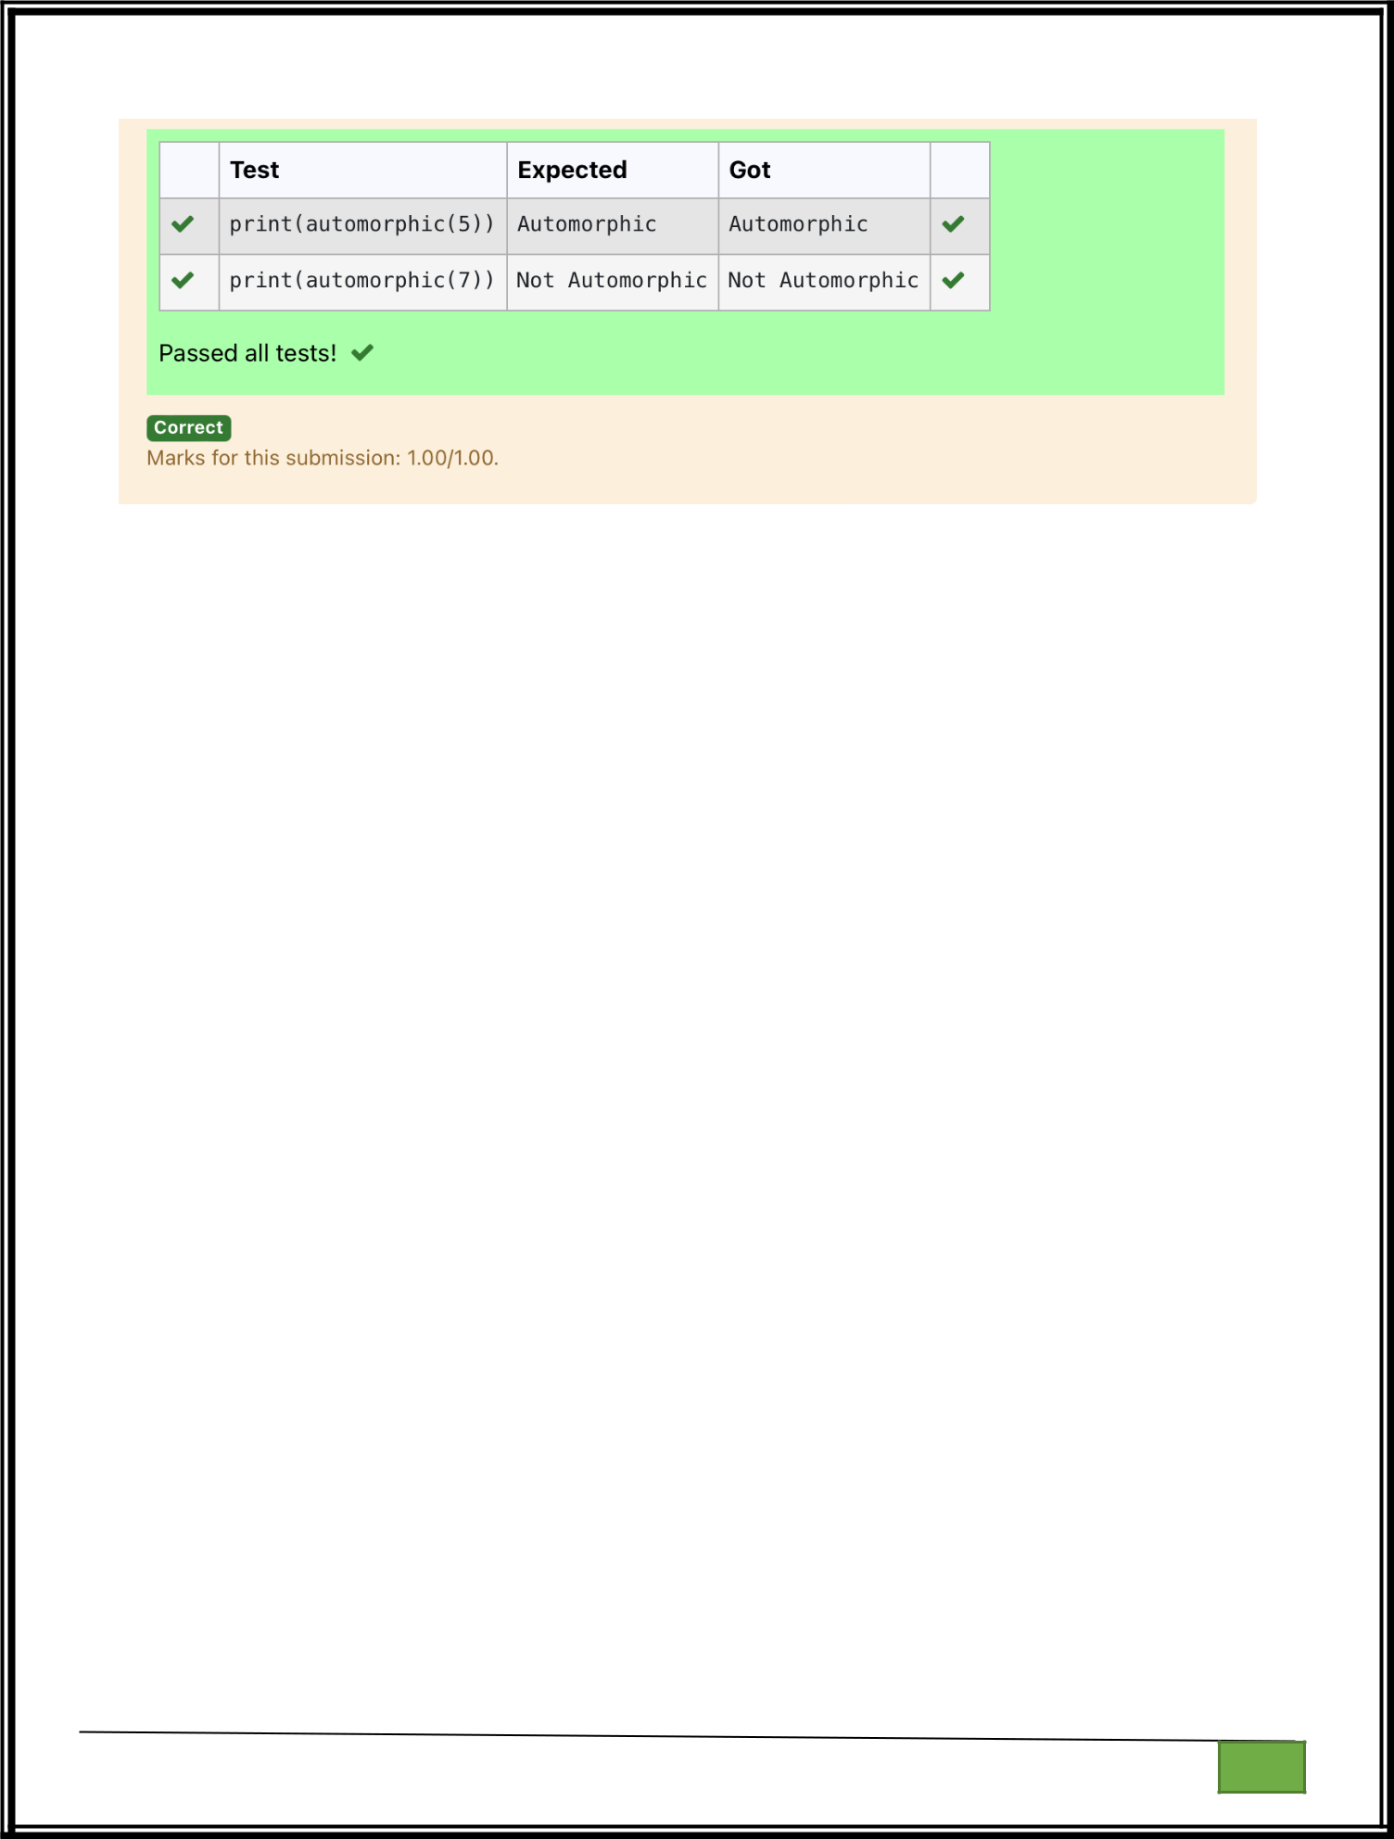

Department of Computer Science and Engineering

| Rajalakshmi Engineering College

PA. GE

Department of Computer Science and Engineering

| Rajalakshmi Engineering College

PA. GE

Ex. No. : 7.3 Date: 09.05.2024

Register No.: 231401020 Name: BHUVANESWARI S

Check Product of Digits

Write a code to check whether product of digits at even places is divisible by sum of digits at odd place of a positive integer.

Input Format:

Take an input integer from stdin.

Output Format:

Print TRUE or FALSE.

Example Input:

1256

Output:

TRUE

Example Input:

1595

Output:

FALSE

For example:

Test | Result

print(productDigits(1256)) True

print(productDigits(1595)) False

Department of Computer Science and Engineering | Rajalakshmi Engineering College

PA.

GE

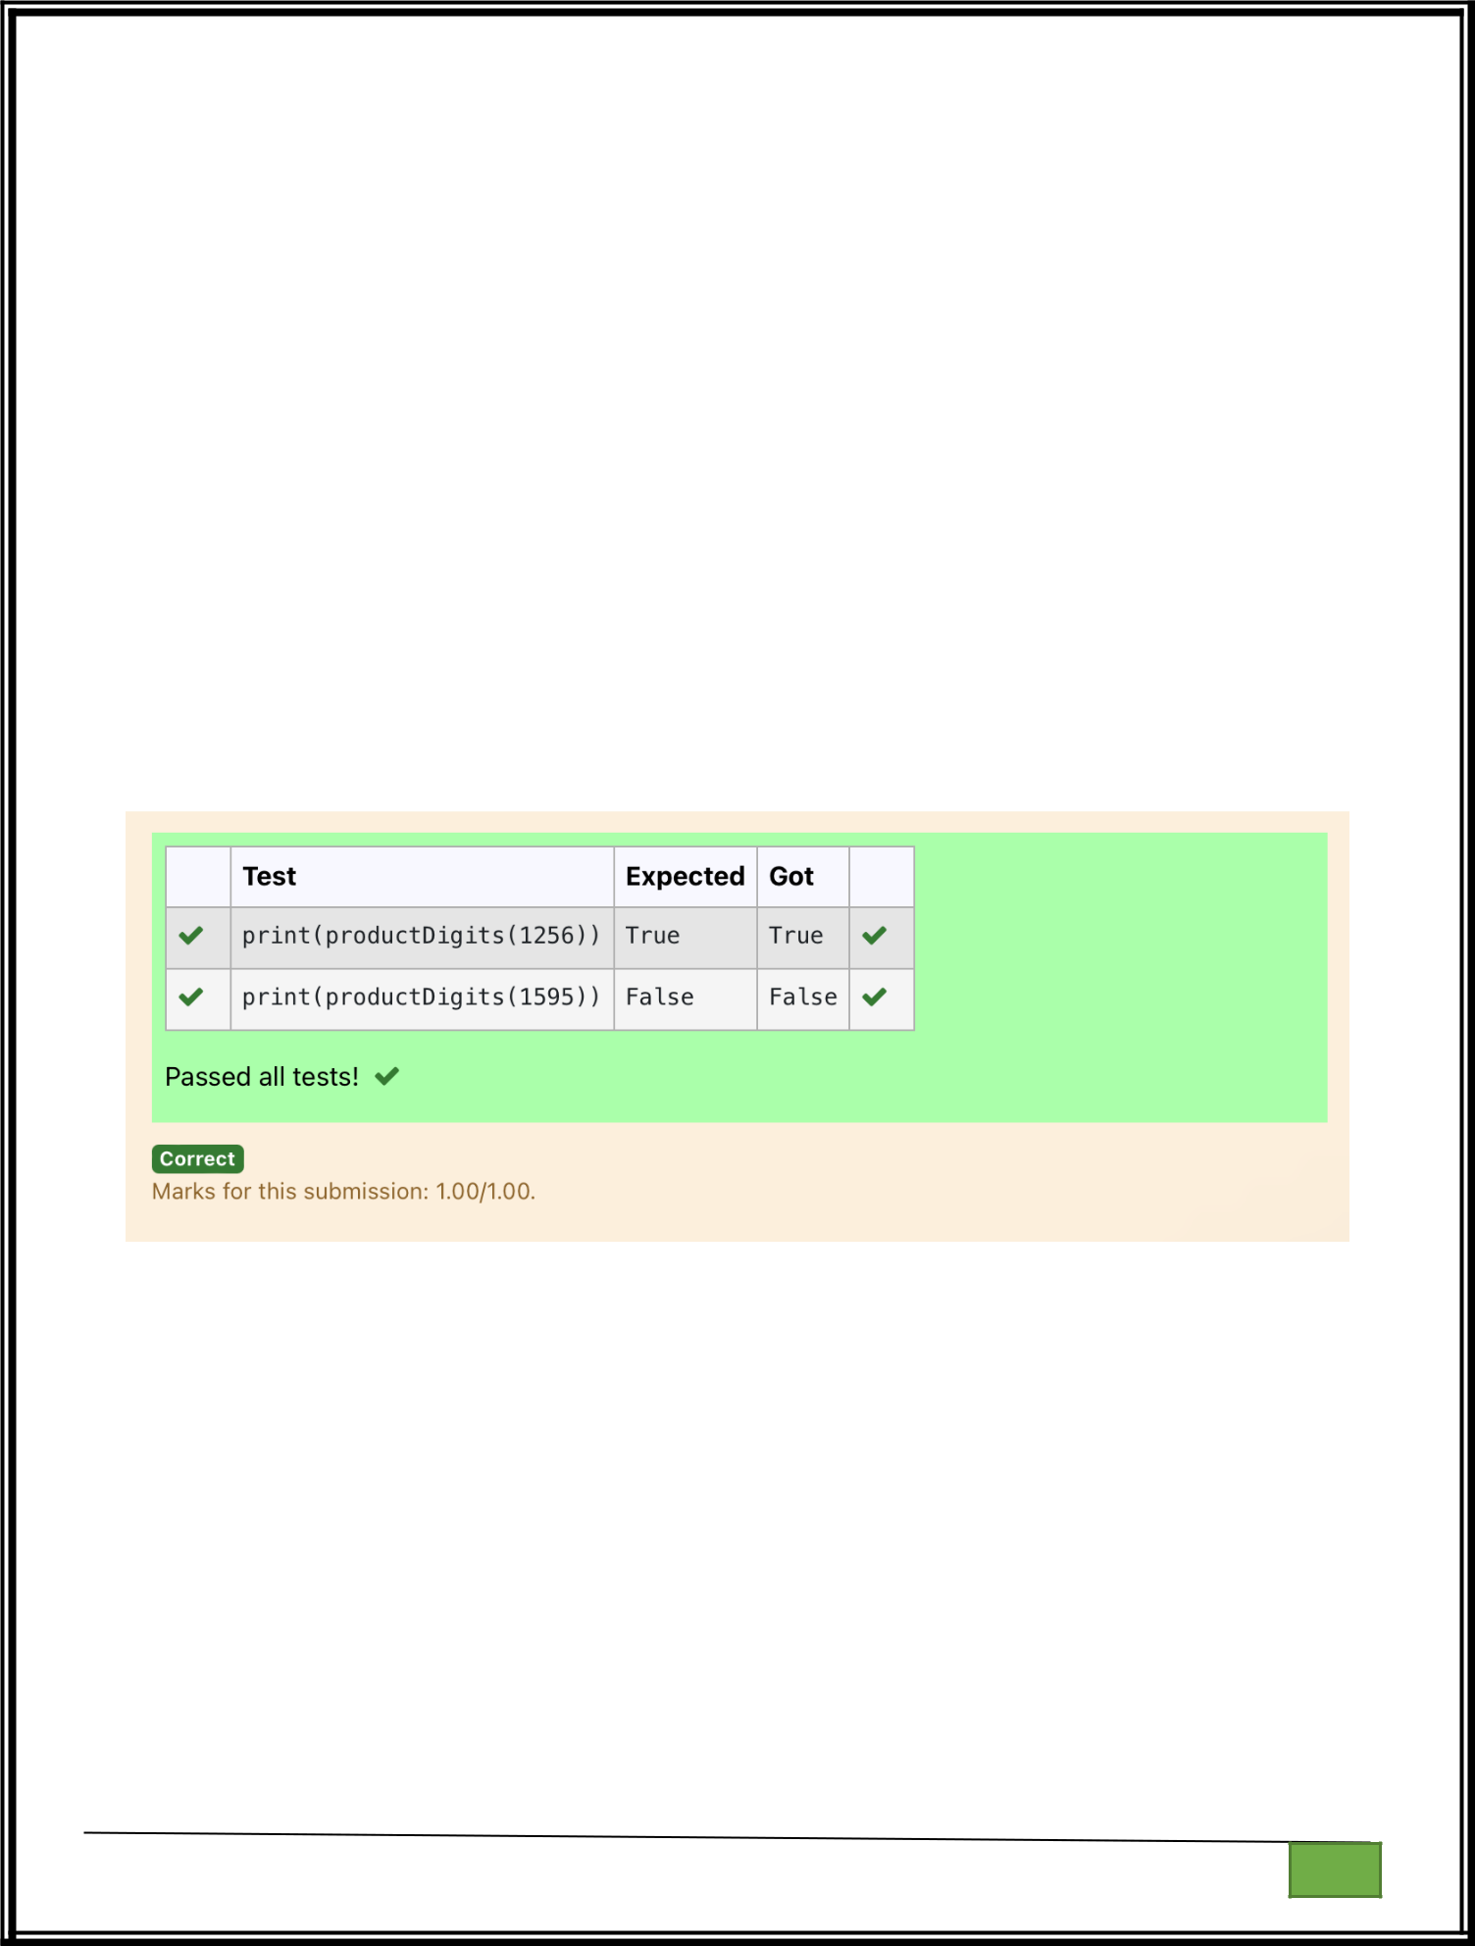
def productDigits(n):

a=str(n)

s,p=0,1

for i in range(0,len(a),2):

s+=int(a[i])

for i in range(1,len(a),2):

p*=int(a[i])

if(p%s==0):

return("True")

else:

return("False")

Department of Computer Science and Engineering

| Rajalakshmi Engineering College

PA. GE

Department of Computer Science and Engineering

| Rajalakshmi Engineering College

PA. GE
Ex. No. : 7.4 Date: 09.05.2024

Register No.: 231401020 Name: BHUVANESWARI S

Christmas Discount

An e-commerce company plans to give their customers a special discount for Christmas. They are planning to offer a flat discount. The discount value is calculated as the sum of all the prime digits in the total bill amount.

Write an python code to find the discount value for the given total bill amount. Constraints

- <= orderValue< 10e100000 Input

The input consists of an integer orderValue, representing the total bill amount. Output

Print an integer representing the discount value for the given total bill amount. Example Input

578 Output 12

For example:

Test | Result
print(christmasDiscount(578) | 12
)

def christmasDiscount(n):

res=0

while n!=0:

rem=n%10

flag=0

for i in range(1,rem+1):

Department of Computer Science and Engineering | Rajalakshmi Engineering College

PA.

GE

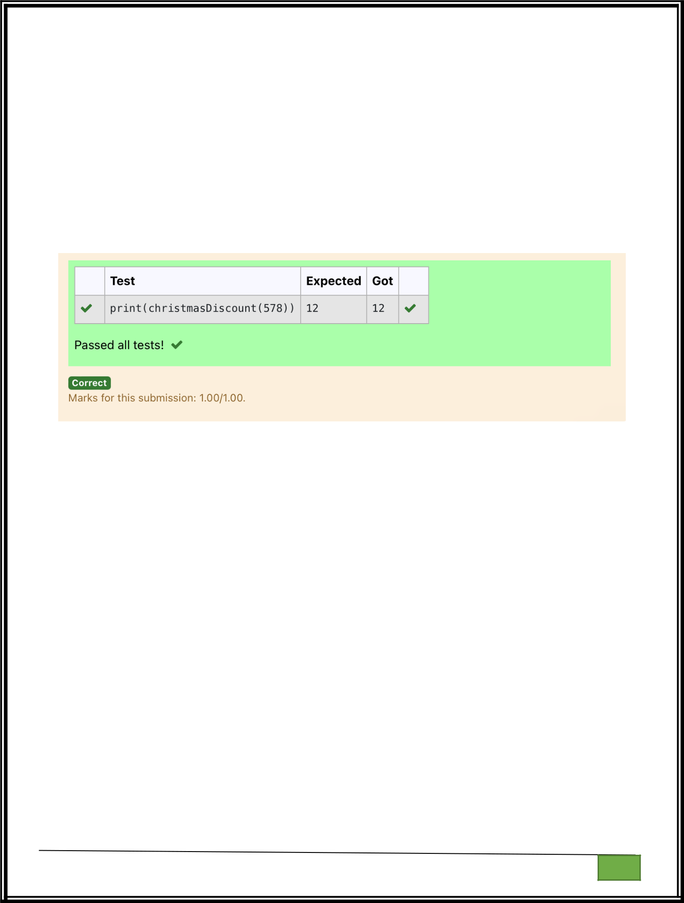
if rem%i==0:

flag+=1

if flag==2:

res=res+rem

n=n//10

return res

Department of Computer Science and Engineering

| Rajalakshmi Engineering College

PA. GE

Department of Computer Science and Engineering

| Rajalakshmi Engineering College

PA. GE
Ex. No. : 7.5 Date: 09.05.2024

Register No.: 231401020 Name: BHUVANESWARI S

Coin Change

complete function to implement coin change making problem i.e. finding the minimum number of coins of certain denominations that add up to given amount of money. The only available coins are of values 1, 2, 3, 4

Input Format:

Integer input from stdin.

Output Format:

return the minimum number of coins required to meet the given target.

Example Input:

16

Output:

4

Explanation:

We need only 4 coins of value 4 each

Example Input:

25

Output:

7

Explanation:

We need 6 coins of 4 value, and 1 coin of 1 value

def coinChange(amount):

- Available coin denominations coins = [1, 2, 3, 4]

- Initialize a list to store the minimum number of coins for each amount from 0 to the target amount

Department of Computer Science and Engineering | Rajalakshmi Engineering College

PA.

GE

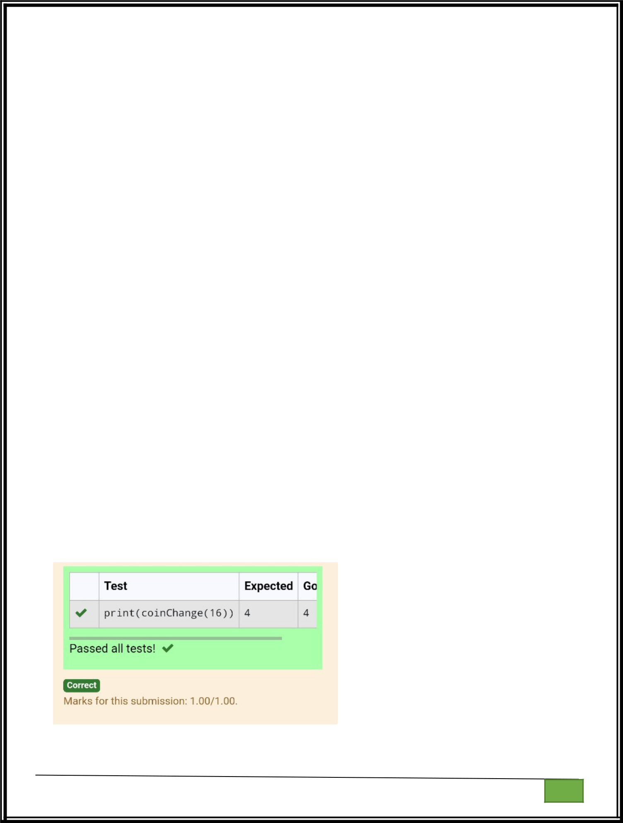
dp = [float('inf')] * (amount + 1)

dp[0] = 0 # Base case: 0 coins needed to make amount 0

- Iterate through all amounts from 1 to the target amount for i in range(1, amount + 1):

- Iterate through all available coin denominations for coin in coins:

  - If the current coin denomination is less than or equal to the current

amount

if coin <= i:

- Update dp[i] to be the minimum between its current value and dp[i - coin] + 1

dp[i] = min(dp[i], dp[i - coin] + 1)

- The result is stored at dp[amount] return dp[amount]

amount = int(input()) print(coinChange(amount))

Department of Computer Science and Engineering | Rajalakshmi Engineering College

PA.

GE

Department of Computer Science and Engineering

| Rajalakshmi Engineering College

PA. GE

Department of Computer Science and Engineering

| Rajalakshmi Engineering College

PA. GE
Ex. No. : 7.6 Date: 09.05.2024

Register No.: 231401020 Name: BHUVANESWARI S

Difference Sum

Given a number with maximum of 100 digits as input, find the difference between the sum of odd and even position digits.
Input Format:

Take a number in the form of String from stdin.

Output Format:

Print the difference between sum of even and odd digits

Example input:

1453

Output:

1

Explanation:

Here, sum of even digits is 4 + 3 = 7

sum of odd digits is 1 + 5 = 6.

Difference is 1.

Note that we are always taking absolute difference

def differenceSum(n):

a=[]

b=[]

k=str(n)

for i in range(len(k)):

if int(i)%2==0:

a.append(int(k[i]))

else:

Department of Computer Science and Engineering | Rajalakshmi Engineering College

PA.

GE

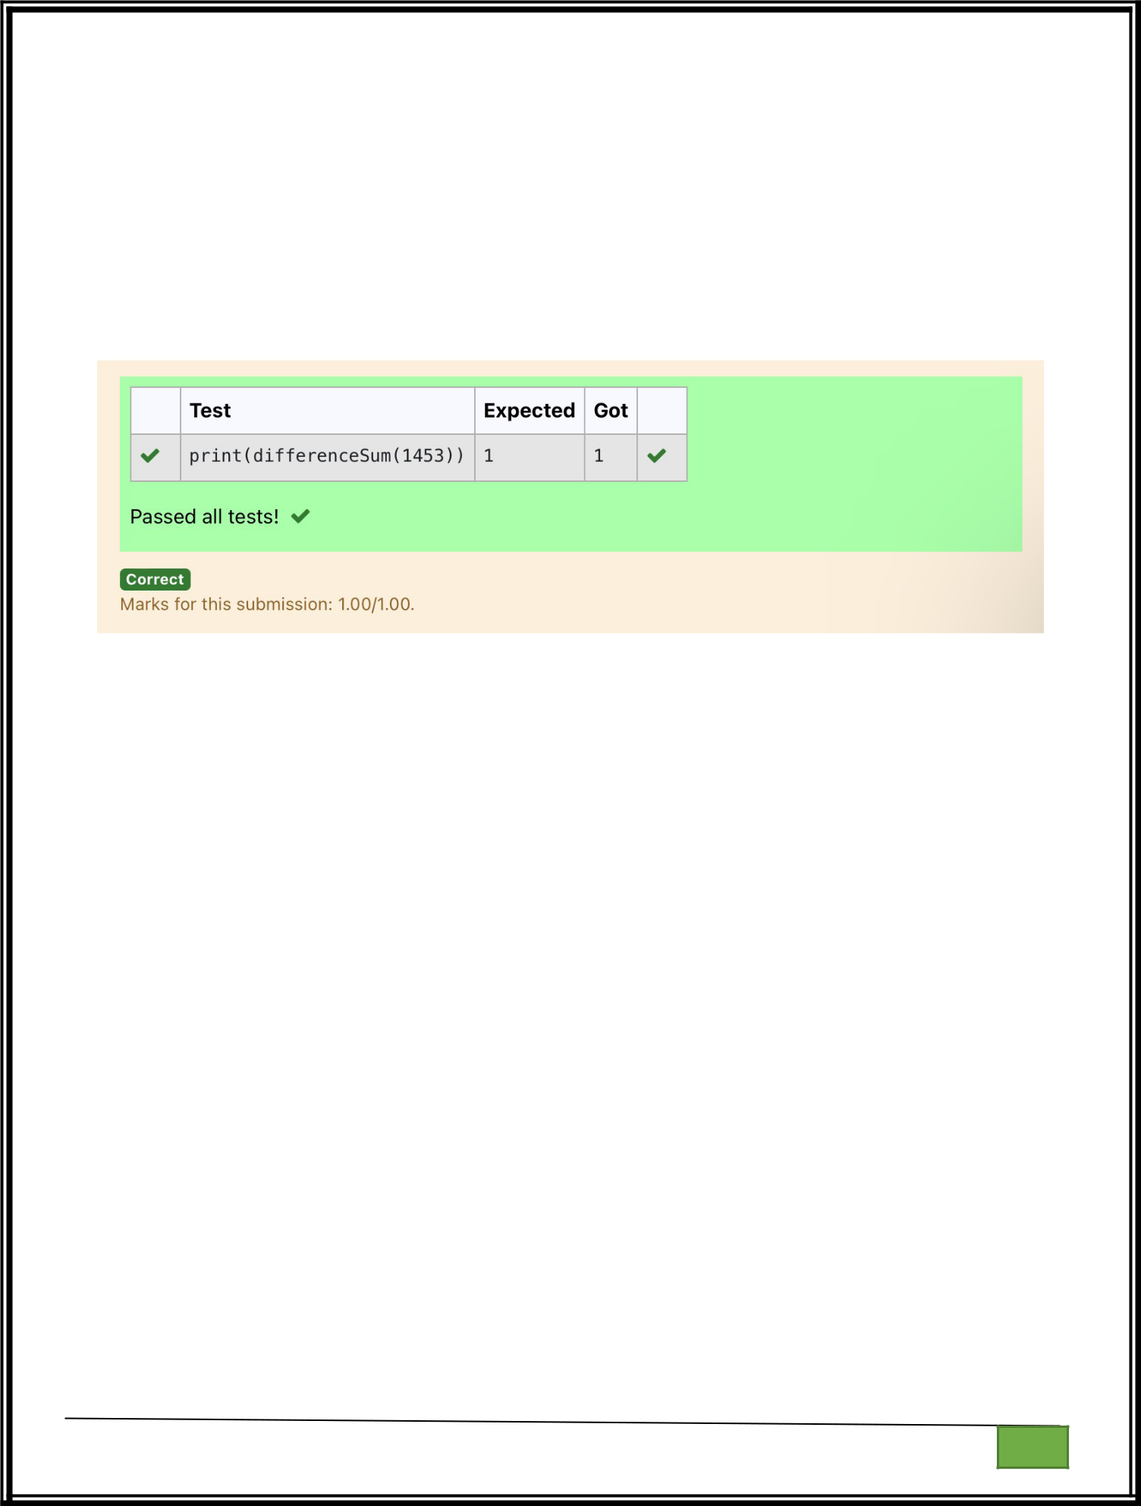
b.append(int(k[i]))

s=sum(b)

r=sum(a)

j=s-r

return j

Department of Computer Science and Engineering

| Rajalakshmi Engineering College

PA. GE

Department of Computer Science and Engineering

| Rajalakshmi Engineering College

PA. GE
Ex. No. : 7.7 Date: 09.05.2024

Register No.: 231401020 Name: BHUVANESWARI S

Ugly number

A number is considered to be ugly if its only prime factors are 2, 3 or 5. [1, 2, 3, 4, 5, 6, 8, 9, 10, 12, 15, …] is the sequence of ugly numbers. Task:

complete the function which takes a number n as input and checks if it's an ugly number. return ugly if it is ugly, else return not ugly

Hint:

An ugly number U can be expressed as: U = 2^a * 3^b * 5^c, where a, b and c are nonnegative integers.

For example:

Test | Result
print(checkUgly(6)) | ugly
print(checkUgly(21) | not ugly
)

def checkUgly(n):

for i in range(n):

for j in range(n):

for k in range(n):

if(n==(2**i)+(3**j)+(5**k)):

return("ugly")

return("not ugly")

Department of Computer Science and Engineering | Rajalakshmi Engineering College

PA.

GE

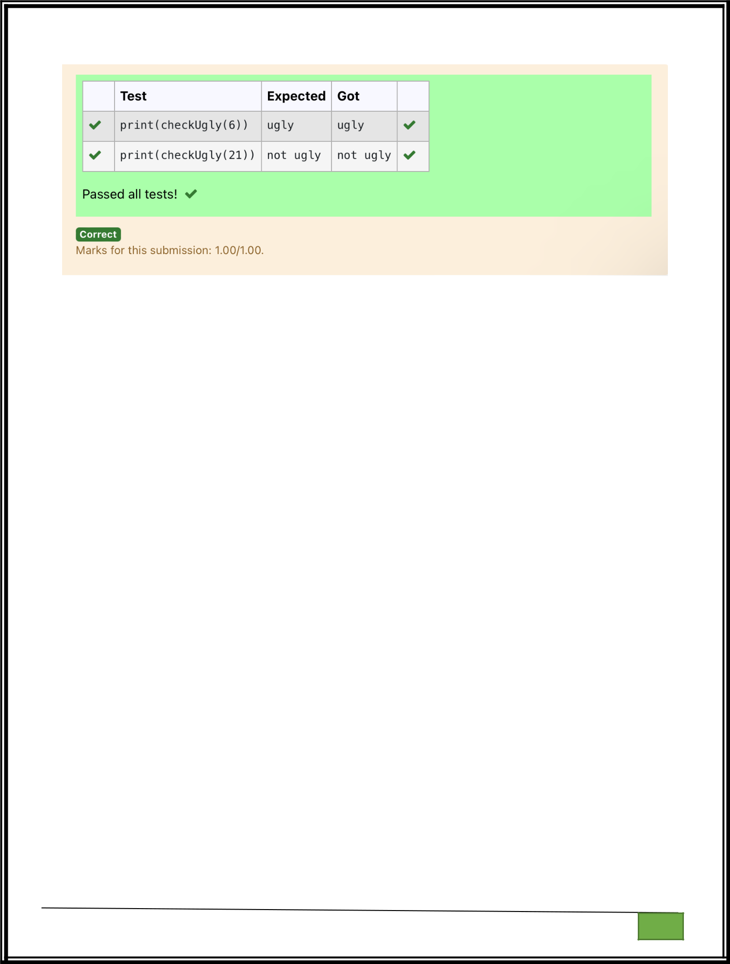

Department of Computer Science and Engineering

| Rajalakshmi Engineering College

PA. GE

Department of Computer Science and Engineering

| Rajalakshmi Engineering College

PA. GE

